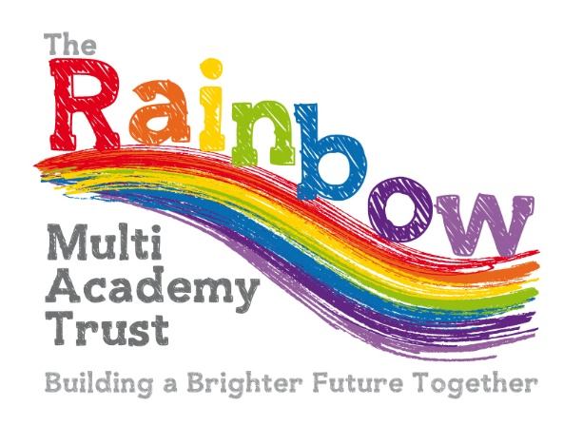

Uniform Policy

|  |  |  |
| --- | --- | --- |
| **Approved by:** | Finance & Resource Committee | **Date:** 12/06/24 |
| **Last reviewed:** | June 2024 | |
| **Next review due by:** | June 2026 | |

**Introduction**

It is our policy that all children should wear school uniform when attending school, or when participating in a school-organised event outside normal school hours. Our policy has been developed taking into account the Department for Education’s [Cost of School Uniforms](https://www.gov.uk/government/publications/cost-of-school-uniforms) guidance.

**Aims and objectives**

Our policy is based on the notion that a school uniform:

* promotes a sense of pride in the school;
* engenders a feeling of community and belonging;
* is practical and smart;
* identifies the children with the school;
* is not distracting in class;
* makes children feel equal to their peers in terms of appearance;
* is regarded as suitable, and good value for money, by most parents;
* has been designed with health and safety in mind.

**Our School Uniform**

* School sweatshirt (royal blue)
* School cardigan (royal blue)
* School fleece (royal blue)
* Polo shirt/ Shirt (white)
* Trousers, skirt, pinafore dress or shorts (black or dark grey)
* Summer dress (blue and white)
* Socks plain– grey / white / black
* Tights plain – grey / black
* Black shoes only (no trainers, no heels, no skate shoes or dolly shoes etc please)

**Please ensure that all uniform is clearly labelled with your child’s name.**

**PE kit**

* PE T-shirts (White)
* Shorts (Black- no logos please)
* Trainers or plimsolls (Black)
* Black track-suit bottoms / sports leggings for the winter months only (no logos please)
* Bag to keep kit together – please ensure this is labelled

**Extra items**

* Blue book bag
* Named water bottle to be kept in school (essential).
* Swimming Kit – Costume / trunks, towel and a swimming hat/goggles as and when required per year group.
* Carne Class- Wellington boots to be named and kept in school.
* Children need to have a coat in school all through the Autumn and Spring terms please, children will not be permitted to be outside without one on cold / damp days.
* Sun hat on sunny days
* Wild Tribe kit - Wellington boots, waterproof trousers and jacket, long sleeved t-shirt, Jogging bottoms / leggings, sweatshirt, spare socks and underwear, plastic bag for wet clothes

**Uniform Supplier**

If you would like our school logo on items our supplier is <https://www.schooltrendsonline.com/uniform/VeryanCofEPrimarySchoolTR25QA>

Here you can find a full range of embroidered uniform with the school logo as well as the ability to purchase other uniform items.

**Jewellery**

* Children are NOT permitted to wear jewellery items at school; rings, necklaces, bracelets etc.
* We do permit watches as long as there is no connection to the internet or photograph facility.
* Simple stud earrings only may also be worn but these would have to be removed or covered in PE sessions.
* All valuables will be worn at the owners risk and the school will not take any responsibility for damage or loss.

**Hair + Nails**

* Shoulder length or longer for all genders should be tied up, due to a distraction of learning when working together in partnered situations and it also avoids the risk of head lice.
* Hair must also be tied up for PE, forest school and design technology sessions please for health and safety reasons.
* Unnatural hair dye is not permitted.
* Hair ties, bands and clips should be in keeping with the school colours of Blue, black, grey, white
* Jo-jo bows and / or other vibrant large accessories will not be permitted.
* Nails are expected to be kept to a reasonable length to avoid accidents of scratching when playing or being in ball games.
* Nail varnish is NOT permitted.

**Not required**

* Pencil cases are not required as all equipment is provided, however should children wish to bring their own items in this would be limited to one pencil case per child and would be brought in at the owners own risk.

**The Role of Parents**

We ask all parents /carers who send their children to our school to support the school uniform policy. We believe that parents/carers have a duty to send their children to school correctly dressed and ready for their daily learning. Parents /carers should ensure that their child has the correct uniform, and that it is clean and in good repair.

**Equal Opportunities**

The school welcomes children from all backgrounds and faith communities. If there are serious reasons, e.g. religious objections, why parents want their child to wear clothes that differ from the school uniform, the school will look sympathetically at such requests. Similarly, should an item of school uniform prove problematic for a pupil with disabilities, then parents are invited to draw this to the attention of the Headteacher. The school will not treat pupils with disabilities unfavourably.

If any parent /carer would like the school to modify the uniform policy, they should make representation, in the first instance, to the Headteacher.

Parents/ carers are encouraged to speak to the class teacher or a member of the Senior Leadership Team, if they are struggling to purchase appropriate uniform, due to financial concerns.

**Second Hand Uniform**

Please note that we have many second-hand items available which have come from past pupils and have all been washed ready to be re-used, please contact the school office if we can support you with any of these items.

**Monitoring and Review**

When monitoring this policy, the Local Governing Board will:

* seek the views of parents/carers, to be sure that they agree with the policy, and support it;
* consider with the Headteacher, any requests from parents for individual children to have special dispensations;
* require the Headteacher to report to the Governors on the way in which the policy is being implemented.